**Design Data Warehouses For Given Below Products:**

**Note :** While designing any Data Warehouse make sure to cover given below points. a. Design Fact & Dimension tables

b. Create meaningful Primary & Foreign keys

c. Try to follow Star/SnowFlake Schema Design

d. Try to write few SQL queries to generate insightful business metrics (This is the critical point because you need to understand the Data & Business both)

1. Design a Data Warehouse for IPL Cricket Tournament **(Asked in Flipkart Interview for Senior Data Engineer role)**

ANS:

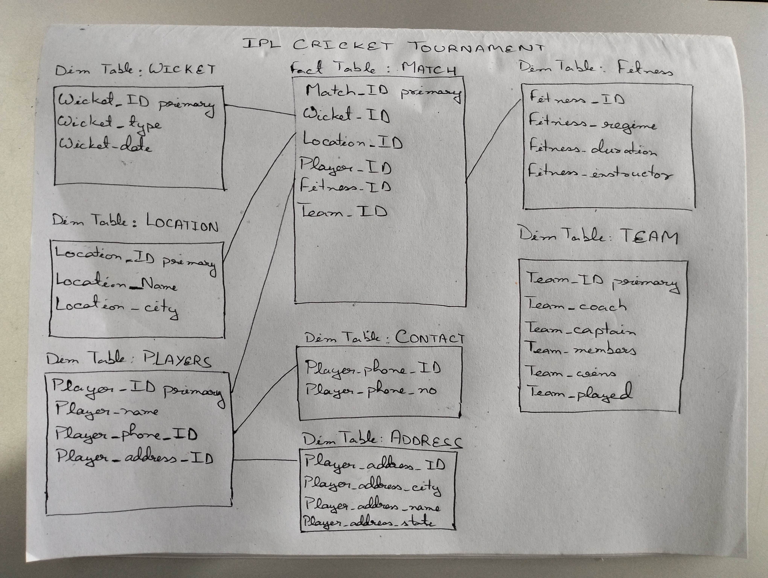

1. Design a Data Warehouse for Food delivery app like Swiggy, Zomato **(Asked in Grab for Data Engineer role)**

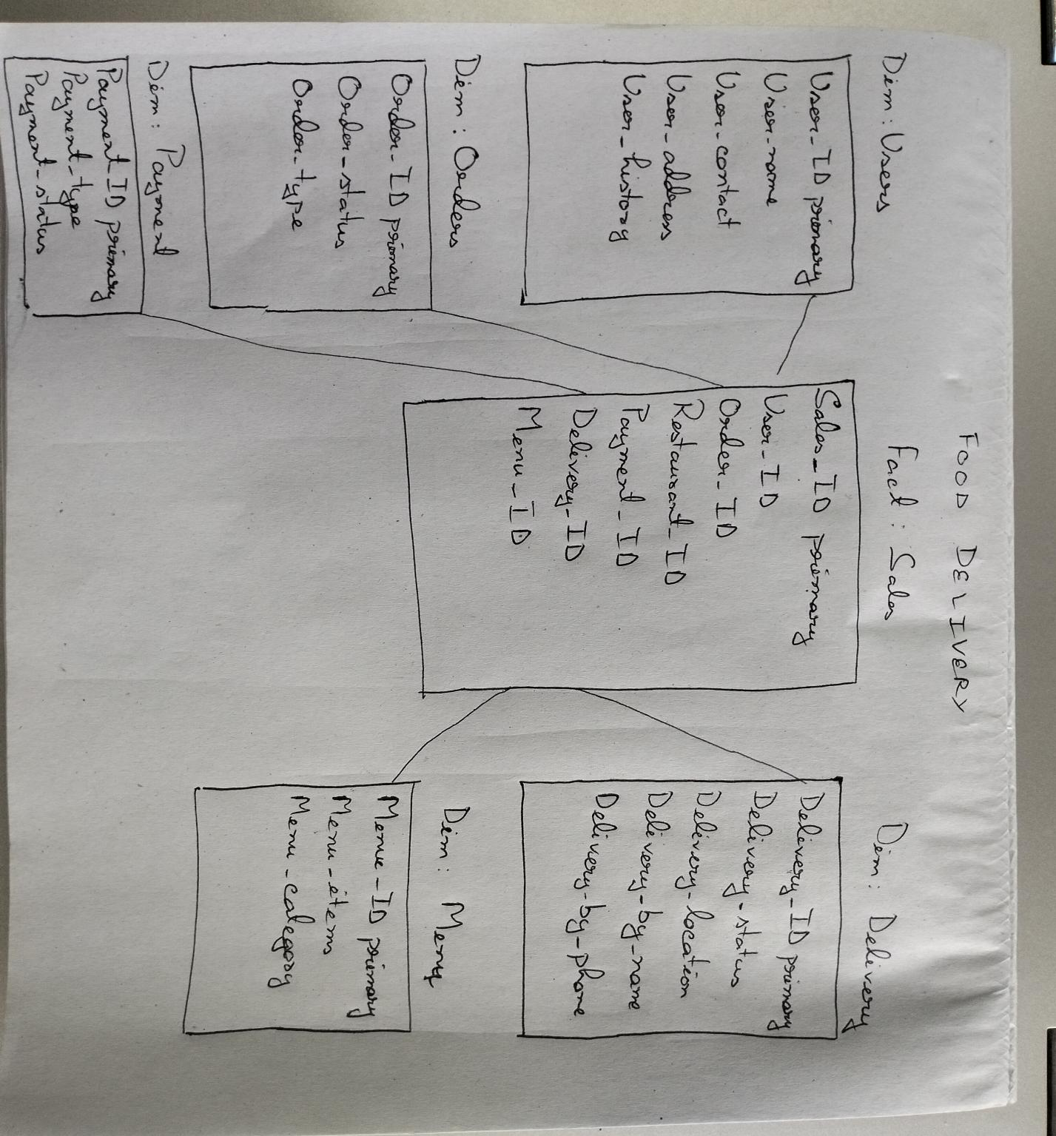

1. Design a Data Warehouse for cab ride service like Uber, Lyft **(Asked in Google for Data Engineer role)**

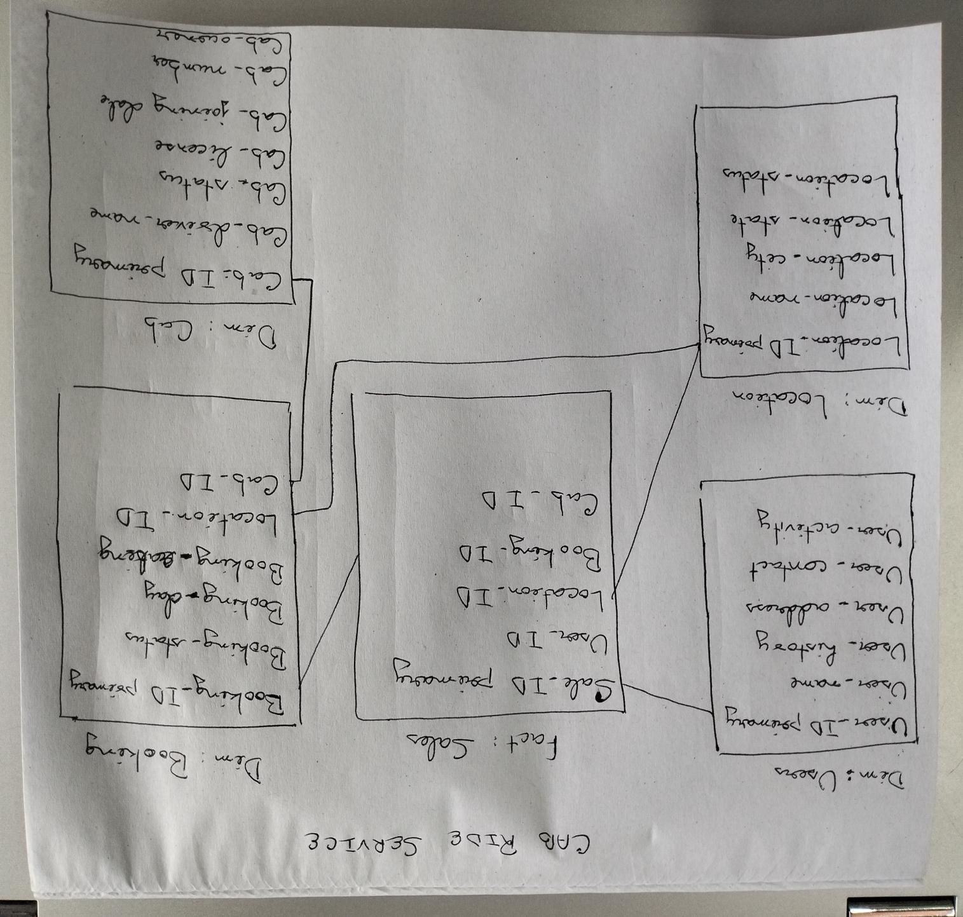

1. Design a Data Warehouse for Restaurent table booking app like Dineout **(Asked in McKinsey for Consultant Data Engineer role)**

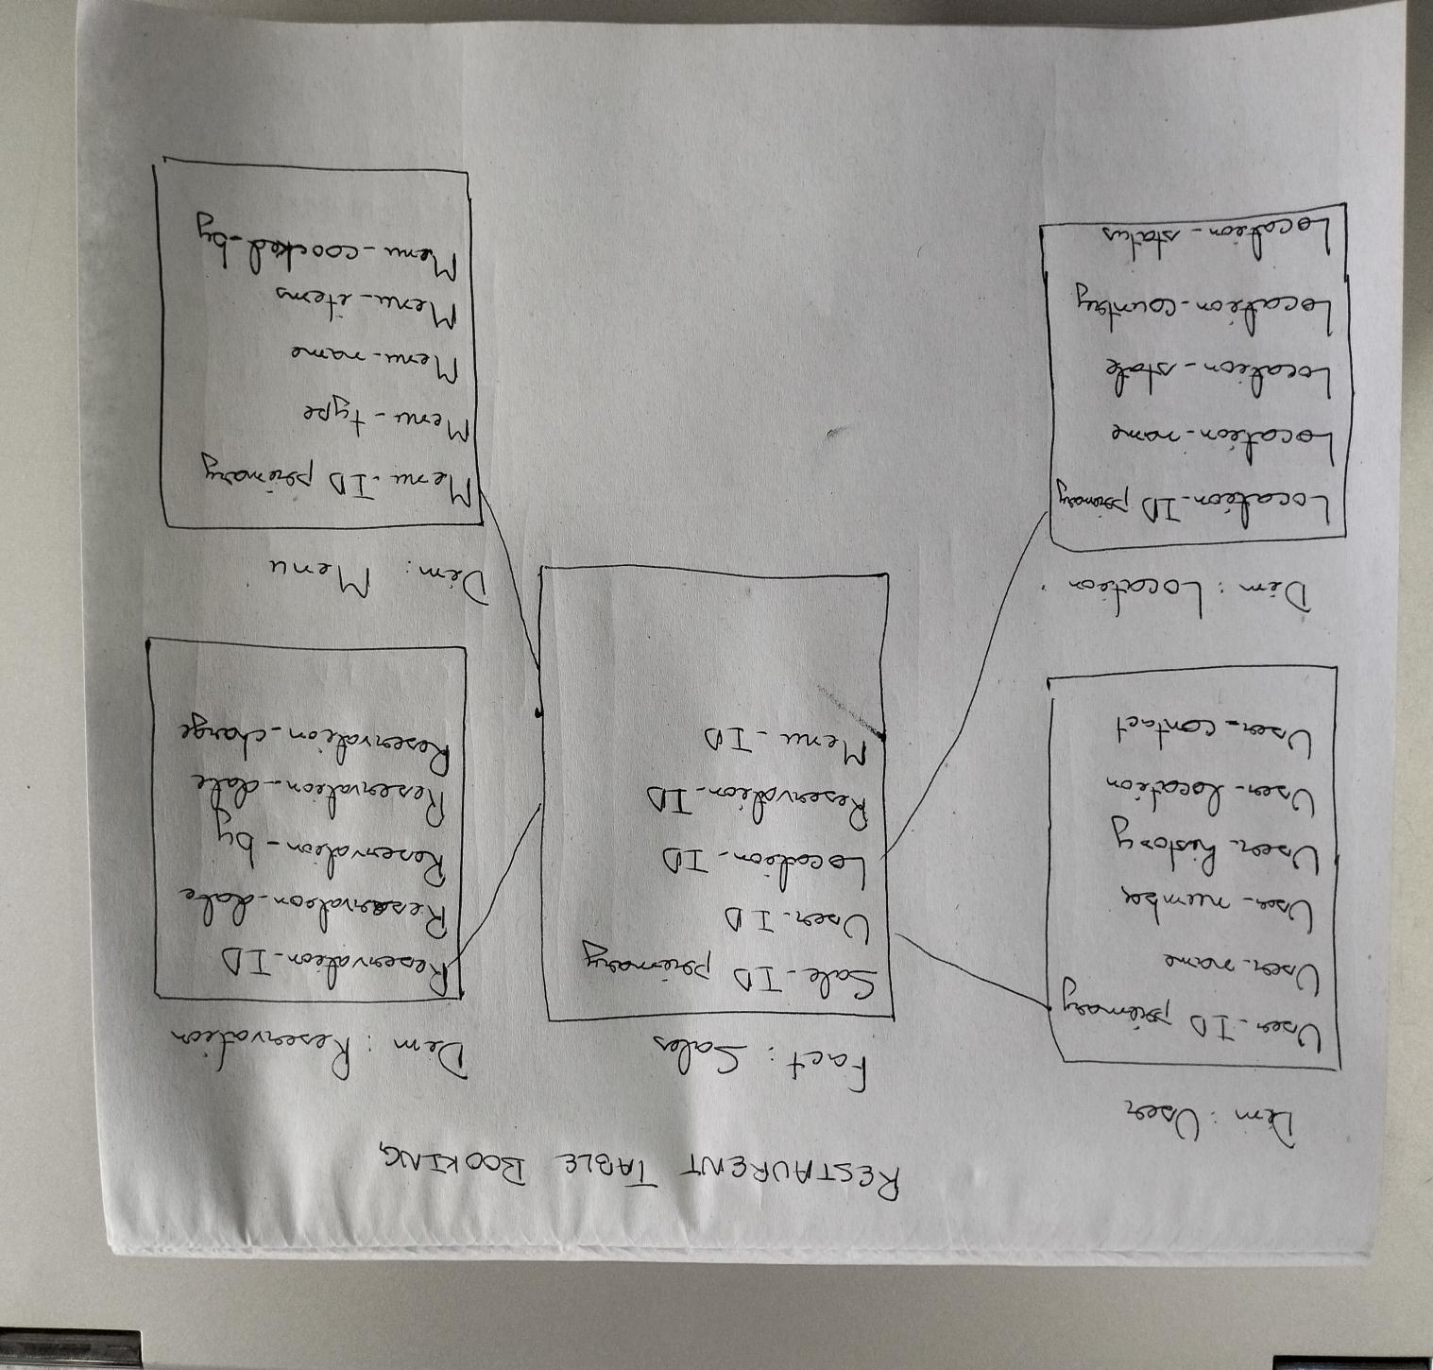

1. Design a Data Warehouse for Covid Vaccination Application **(Asked in Livsapce for Data Engineer role)**

